Online Testing Access Guide
Access to Online Testing is available through our online testing platform – BLUEPANDA E-TESTING

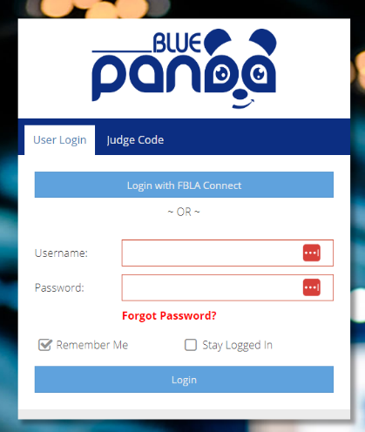
Obtain Online Testing Logins
for Students (BluePanda)

- Login to BluePanda at https://app.gobluepanda.com
Note: To login, use the “Login with FBLA Connect” button for single-sign on access with your FBLA Connect account login

- Once logged in, you will see a box under Current Events for the conference. Along the right hand side are different option buttons. For access to logins, click the button E-Testing Login Cards.

- The system will generate a document with login cards for each student that can be printed and distributed.
Sample Login Cards
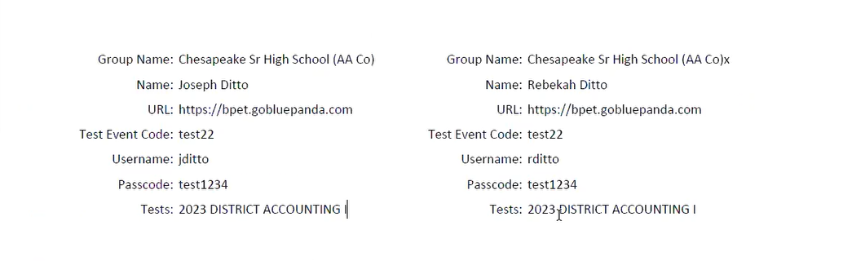

Online Testing Guidelines
- Objective tests must be completed within the testing time limit specified in the national guidelines (50 minutes for high school tests and 30 minutes for middle school tests)
- Each student is expected to follow the FBLA honor code. See Honor Code for Online Testing on next page.
- All tests must be done with a test proctor. A proctor is an adult who ensures proper administration of tests during the any online testing. The proctor oversees protecting the integrity of the tests and proper administration of tests in the online testing site. Please reference the Testing Proctor Instructions document for more information.
- All tests will be securely monitored by the state management team in the system. Should a participant navigate away from the test for a significant amount of time or switch between browser tabs, they will get locked out of their test. To reopen the test, the test proctor/chapter adviser needs to contact the state management team via our website or email at hello@nevadafbla.org. Requests from students will not be accepted without approval from the adviser.
- Aligning with National guidelines, all team events that have a testing component must be taken INDIVIDUALLY and all the scores will be averaged. Should a student registered with the team not complete their online test, they will be disqualified from the team and be removed from the average. They will also not be recognized during the Awards Session.

Questions?
Please contact your state management team for assistance. You can also live chat with our virtual concierge during our online office hours Monday – Friday from 8 am – 5 pm! Visit our state website: nevadafbla.org

FBLA Honor Code for Online Testing
Integrity and honor are integral elements of ethical, responsible leadership. In a community devoted to learning, a foundation of integrity and honor among individuals must exist if that community is to thrive with respect and harmony among its members. Great care must be taken in maintaining academic integrity and honor while preparing students/members for their future careers, and as they grow into future leaders. It is the individual responsibility of every member, local adviser, and state adviser to maintain and enforce these standards. To administer such a high standard across our organization, every competitor must agree and certify to the compliance of the following guidelines for any competitive event into which they are registered:
- The contents of this FBLA competitive event entry, and any answers or solutions provided, are solely the work of the undersigned competitor and/or his/her team members.
- The FBLA competitive event guidelines related to this event were read and followed, along with any supplemental guidelines for the conference.
- No help was sought beyond that allowed in any FBLA competitive event instructions or guidelines.
- No more time was taken than allowed by FBLA competitive event guidelines.
- No FBLA competitive event or test materials will be or have been saved to any storage device remaining in the possession of the undersigned competitor(s) or that of any other person; nor has it been saved to any cloud storage.
If a violation is determined to have occurred, the competitor will be subject to penalties of point deductions or disqualification at the determination of FBLA, and information will be forwarded to the appropriate state FBLA organization for potential action of academic integrity violations.

