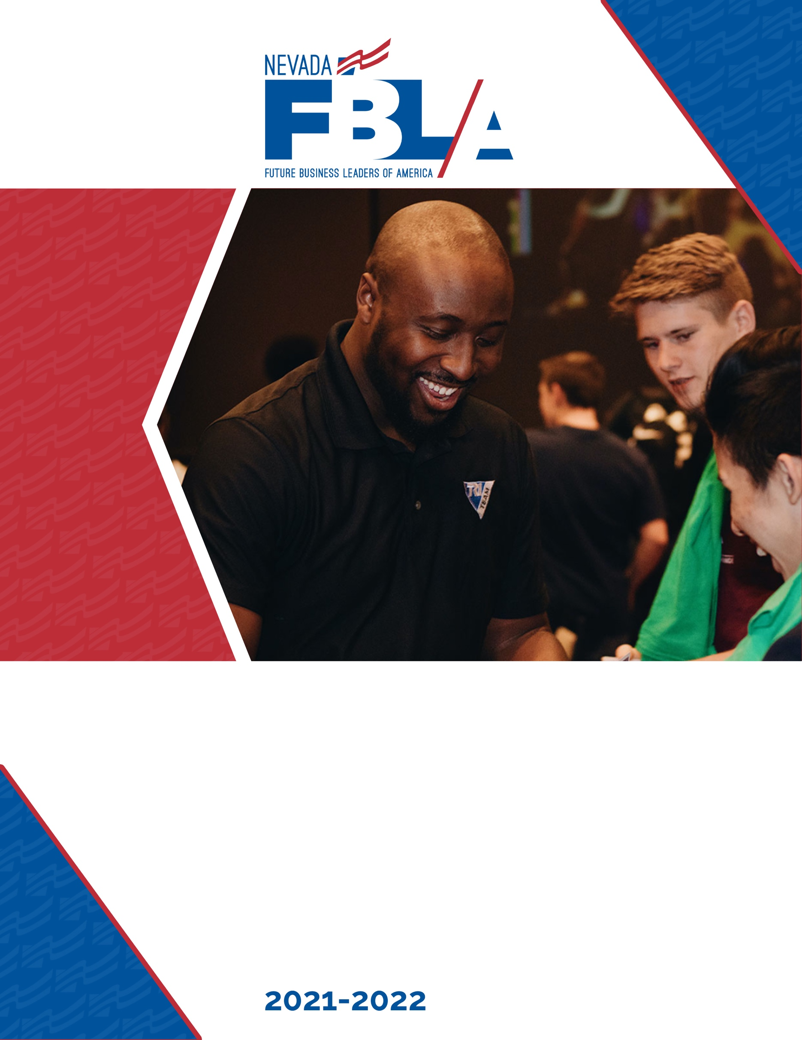

Region Success Series Competition Guide
2021-2022 Region Success Series
Nevada FBLA is pleased to announce the Region Success Series continues this year! The Region Success Series will allow members to compete against others from their region in all events with an objective test component.

Who
All members of Nevada FBLA are encouraged participate. This activity is also great for chapters pursuing the Champion Chapter award.

What
This is a competition only open to current Nevada FBLA members. Members compete against others in their region with additional state-level recognition. Participants attending SBLC will receive RSS ribbons.

When
Registration will open November 30 and close at 5:00 pm on January 7.
No changes will be made after 5:00 pm on January 7.
Advisers will receive testing log-in information by 5:00 pm on January 14.
Testing begins at 8:00 am on January 18.
Testing closes promptly at 5:00 pm on February 1.
There is no late registration for this event.
Winners will be announced February 8.
Advisers will have access to scores and competency reports the week of February 14.

Where
Online! For the competition, the only requirement is that tests be taken in your school environment. They may not be completed at home. However, we are not requiring a non-business educator proctor so that tests can be taken at a time convenient to members and advisers.

Winners will be announced and recognized on social media, Nevada FBLA website and the adviser weekly update.

Testing
Advisers will receive an email from the testing company with adviser credentials. Keep this email. With the credentials you can access student login cards prior to testing. After the competition winners are announced, advisers will be able to access scores and results based on each test’s competencies to help determine events for SBLC competition and to assist in event preparation.

Each test is taken as an individual – there are no collaborative or team events during this online competition.

Competitions
There are no limits on the numbers of competitors per event a chapter may have. Each member may participate in 5 (five) online tests.

FBLA Competitions:

Accounting I
Accounting II
Advertising
Agribusiness
Banking and Financial Systems
Business Calculations
Business Communications
Business Law
Business Management
Computer Applications
Computer Problem Solving
Cyber Security
Database Design & Application
Economics
Entrepreneurship
Healthcare Administration
Help Desk
Hospitality & Event Management
Human Resource Management NEW
Insurance & Risk Management
International Business
Introduction to Business Communication*
Introduction to Business Concepts*
Introduction to Business Procedures*
Introduction to Event Planning*
Introduction to FBLA*
Introduction to Financial Math*
Introduction to Information Technology*
Introduction to Parliamentary Procedures*
Journalism
Management Information Systems
Marketing
Network Design
Networking Infrastructures
Organizational Leadership
Parliamentary Procedure
Personal Finance
Political Science
Securities and Investments
Sports and Entertainment Management
Spreadsheet Applications
Supply Chain Management
UX Design NEW
Word Processing

*Indicates events limited to members in 9-10 grade.

Middle Level
Business Etiquette
Career Exploration
Digital Citizenship
Exploring Computer Science
Exploring Economics NEW
Exploring Technology NEW
FBLA Concepts NEW
Financial Literacy
Interpersonal Communication NEW
Leadership NEW
Learning Strategies NEW
Running Effective Meetings NEW

Registration Process
The cost is $10 per member to participate in this competition. Registration is online through BluePanda. Changes to events will only be accepted through the registration period.

We will be using BluePanda for registration. To access BluePanda go to
app.gobluepanda.com.
The username is your NVFBLA_Chapter# (Example: NVFBLA_3797)
The password is “service.”

Only FBLA or Middle Level members are eligible to participate. A member is defined as a student with paid membership in the national system. It can take up to 24 hours for membership to show paid in the national and BluePanda systems once paid by credit card.

Select students to participate first, then add the competitons to the students.

A generic invoice will be automatically generated. An official invoice from Nevada FBLA will be sent to the adviser address listed in the registration process. Invoices from RSS must be paid before the chapter will be able to register for SBLC.

Questions
If you have any questions regarding the competitive events or BluePanda, email us at registration@nevadafbla.org

